|  |  |  |
| --- | --- | --- |
| SR.No | Title | Page No |
| 1. | **Introduction**   * Introduction. * Existing System. * Proposed system. * Need and scope of the system | 1-7 |
| 2. | **System Requirement Specification**   * System Requirement * Features of .NET * Features of SQL Server | 8-12 |
| 3. | **System Diagram**   * Data Flow Diagram * First Level DFD * Entity Relationships Diagram * Use case diagram * Site map | 13-20 |
| 4. | **System Design**   * Database Diagram * Input Design * Output Design | 21-64 |
| 5. | **Future Enhancement** | 65-66 |
| 6. | **Conclusion** | 67-68 |
| 7. | **References** | 69-70 |
|  |  |  |

**INTRODUCTION**

* 1. **Statement of the problem**

Today’s world is being computerized. Being faster is necessary for every human being as their basic needs. To run with the faster world, it is necessary to be fast and accurate.

Sometimes, for minor but valuable things, great human efforts are required which are very expensive, to avoid this, we can convert manual system into computerized system.

The project entitled “JOB PORTAL” is a software package. It is an online website. This portal can handle data of Recruits (Several Companies) who are looking for suitable candidates for their vacancies. This portal will be most useful for Consultants for searching of matching job with jobseekers etc. The classic Functionality of this Application focuses on data storage. However, the means to retrieve and analyze data, to extract, transform and load data, and to manage the data dictionary. An administrator is provided through which can enter Recruiter’s record /type of jobs/jobseeker’s description. A registration form is provided through which user can enter details of company like location of company/type of job/status of job/Qualification of jobseekers. This data once entered can be edited/deleted as required when there will be vast entries of data user can scroll the data.

Our System provide facilities to apply for online job thatdifferent types of category and any Jobseeker can be applythat job.

1. **Existing System**

Presently recruitment is done manually. That is if a company or organization needs employees they make an announcement through newspaper. People who are eligible send application to the organization or company. From this application they are called for interviews or tests. Then after the tests company has to do short listing manually. From these shortlisted candidates, they are called for interviews. After interview short listed candidates are employed.

The existing system of recruitment is totally depended upon paper work, for keeping the record they have to maintain registers which is very difficult work. This method is time consuming and costly. This system requires manual work, it require people for working. If we want to find a record of particular person it is very difficult because for that we have to search many of registers therefore it is time consuming. It is also very difficult to maintain records because there is chance of missing of records and destroy record due to human negligence means working manually is difficult, time consuming, expensive, also unsecured.

**Limitations of existing system**

* Existing system is totally manual.
* It is time consuming process.
* To take information about plants you have to go to that place.
* It is manual system so, there is more waste of paper.
* You cannot generate any type of reports in different formats.

1. **Proposed System**

This system is an online application that can be accessed throughout the organization and outside as well with proper login provided. This system can be used as an application for the Online Placement Agency to manage the member information with regards to placement. Member logging should be able to upload their information in the form of a CV. Visitors/Company representatives logging in may also access/search any information put up by Members.

As security is the major focus, this project also keeps an account of details of its different members. For providing more convenience, this project is designed in such a way that it is more user-friendly and graphical..

**Advantages of proposed system**

* The important reason to make the work easier, faster and less time consuming.
* It is computerized system.
* It saves money and time.
* It is not require visiting the place for registration.
* Easily find information about plants.
* To generate better report for requirement.
* To provide user friendly environment to users to use the system.

**System Requirement**

**Specification**

* 1. **Software Requirements**

IDE : Microsoft Visual Studio 2010

Operating System : Windows 7 and above

Project Platform : .NET

Framework : Framework 4.5

Front End : ASP.NET with C#

Back End : SQL SERVER

**2.2 Hardware Requirements:**

Processor : intelpentium4.1ghz processor

Ram : 512 mbsdram

Hard Disc Space : 80gb& above

Printer : dot matrix / ink jet

Monitor : color or monochrome

**Introduction to ASP.NET with C#**

ASP.NET is a development environment which runs under Microsoft Visual Studio 2005 & 2008. ASP.NET is “Event Driven” because all activities in a program are triggered by one event or another. ASP.NET is also called as “Object based language” because it moves around object/control. Development process in ASP.NET is very fast as compare to Traditional Procedure Oriented Programming. So, ASP.NET is very useful environment for develop web Applications. The basis of this development platform, it consist of two primary components –

1. **Common Language Runtime –**

It is the environment where all programs in .NET are run. It provides various services like memory management & thread management. Programs that run in the CLR need not manage memory, as it is completely taken care by the CLR.

1. **The .NET Framework Base class –**

Software developer uses a personalized set of tools in terms of classes & components. The .NET class library provides a common interface between all the different .NET programming languages.

**Microsoft Visual Studio Editions:-**

**Microsoft Visual Studio 2008**

.NET framework 2.0

.NET framework 3.0

.NET framework 3.5

**Microsoft Visual Studio 2012**

.NET framework 4.5

**Features of .NET –**

**Interoperability**

Because computer systems commonly require interaction between new and older applications, the .NET Framework provides means to access functionality that is implemented in programs that execute outside the .NET environment.

**Common Language Runtime Engine**

The [Common Language Runtime](http://en.wikipedia.org/wiki/Common_Language_Runtime) (CLR) is the execution engine of the .NET Framework. All .NET programs execute under the supervision of the CLR.

**Language Independence**

The .NET Framework introduces a [Common Type System](http://en.wikipedia.org/wiki/Common_Type_System), or CTS. Because of the CTS feature, the .NET Framework supports the exchange of types and object instances between libraries and applications written using any conforming [.NET language](http://en.wikipedia.org/wiki/List_of_CLI_languages).

**Base Class Library**

The [Base Class Library](http://en.wikipedia.org/wiki/Base_Class_Library) (BCL), part of the Framework Class Library (FCL), is a library of functionality available to all languages using the .NET Framework. The BCL provides [classes](http://en.wikipedia.org/wiki/Class_(computer_science)) which encapsulate a number of common functions.

**Simplified Deployment**

The .NET Framework includes design features and tools that help manage the [installation](http://en.wikipedia.org/wiki/Installation_(computer_programs)) of computer software to ensure that it does not interfere with previously installed software, and that it conforms to security requirements.

**Security**

The design is meant to address some of the vulnerabilities, such as [buffer overflows](http://en.wikipedia.org/wiki/Buffer_overflow), that have been exploited by malicious software. Additionally, .NET provides a common security model for all application.

**Introduction to SQL Server:-**

SQL server is a free and easy to use database product. It is designed to provide a database platform that offers superior ease of use, enabling fast deployments for its target scenarios. Features like auto close & the ability to copy database as file which are enabled by default in SQL server , while the high availability & business intelligence features are absent . It is very easy to “scale up”. SQL server was developed with two distinct uses in mind. The first is as server product , especially as a web server or database server . Second is as local client data store where the application data access does not depends on the network. Ease of use and simplicity are the key goals.

The two main usage scenarios of SQL server are:

* Hobbyist building client/server application.
* Non-professional developers building web applications.
* **Security**

For SQL server, one of the goals is to provide secure defaults for the different components. For instance, the networking protocols such as TCP/IP and Named Pipes are turned off. SQL browser service is not started unless the user explicitly asks for this in the setup command line .The SA or system admin account is disabled by default if Windows Authentication is used. Normal users on the machine have almost no privileges on the SQL server instance. A local Administrator on the server must explicitly grant relevant permissions for normal users so that they can use SQL functionality .

* **Attach ‘DB’ Filename**

You can specify a relative or absolute file path for the Attach DB File Name connection string entry. The specified database file is attached when the connection is opened and this database is used as the default database for that connection . If the database is already attached when Attach DB File Name is invoked, then attach does nothing. This keyword supports a special string called **|Data Directory|** that points at runtime to the data directory of the application where database files are stored . This special string should be at beginning of the file path, works only against a local file system, and checks are done for Syntax so that the file path is not higher than the directory pointed to by the substitution string.

* **Auto-Close**

This feature releases the file locks on the user database when there are no active connections to it. Thus, the database is ready to moved or copied after the application that uses it is closed.

**Feature Description**

* **Online Restore**

With SQL server 2005, database administrators are able to platform a restore operation while an instance of SQL Server is running. Online restore improves the availability of SQL Server because only the data being restored is unavailable; the rest of the database remains online and available.

* **Online Indexing Operations**

The online index option allows concurrent modifications (updates, deletes , and inserts) to the underlying table or clustered index data and any associated indexes during index data definition language(DDL) execution. For example , while a clustered index is being rebuilt, you can continue to make updates to the underlying data and perform query against the data.

* **Fast Recovery**

A new faster recovery option improves availability of SQL Server databases. Administrators can reconnect to a recovering database after transaction log has been rolled forward.

* **SQL Server Management Studio**

SQL Server 2005 includes SQL Server Management Studio, a new integrated suite of management tools with the functionality to develop, deploy and troubleshoot SQL Server database, as well as enhancements to previous functionality.

* **Dedicated Administrator Connection**

SQL Server 2005 provides a dedicated administrator connection that administrators can use to access a running server even if the server is locked or otherwise unavailability . This capability enables administrators to troubleshoot problems on a server by executing diagnostic functions or Transact-SQL statements.

* **Hosted Common Language Runtime**

WithSQL Server 2005 developers can create database object using familiar languages such as Microsoft Visual C#.NET and Microsoft ASP.NET. Developers can also create two new objects –user-defined types and aggregates.

* **Native XML Support**

Native XML data can stored, queried, and indexed in SQL Server database -allowing developers to build new classes of connected applications around Web services and across any platform or device.

* **Security Enhancement**

The security model in SQL Server 2005 separates users from objects , provides fine-grain access , and enables greater control of data access. Additionally, all system tables are implemented as views, providing more control over database system objects.

* **Web Services**

With SQL Server 2005 developers can develop Web services in the database tier, making SQL Server a hypertext transfer protocols (HTTP) listener and providing a new type of data access capabilities for Web services access capability for Web service – centric applications.

**System Diagram**

**System Diagram**

**Data Flow Diagram**

DFD is also known as ‘Bubble Chart’. Its purpose is to classify system requirement and identifying major transformation that will become program in a system design. So, it is a starting point of the design phase that functionality decomposes the requirements specifications down to the lowest level of the detail. A DFD consists of series of bubbles joined by lines. The bubbles represents data transmission and line represents data flow in the system.

**Entity Relationship Diagram(ERD)**

Entity relationship diagram graphically represent overall logical structure of database which includes interactions between entity of various ways. Entityu relationship (ERD) illustrates the logical structure of database. Entity relationship ERD’s in 1976 since then Charles Bachman and James Martin have added some slight refinements to the basic ERD principles.

**3.1 Data Flow Diagram**

**3.1.1 Context level Data Flow Diagram**

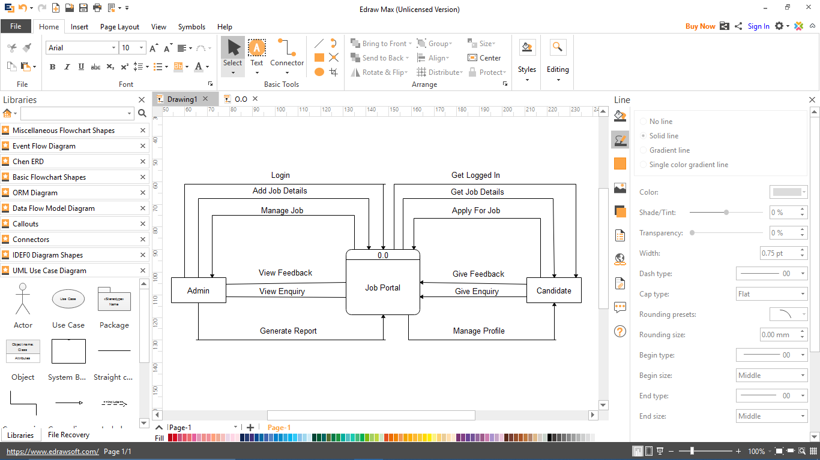

**3.1.2 FIRST LEVEL D.F.D.**

**First level DFD for Admin:-**

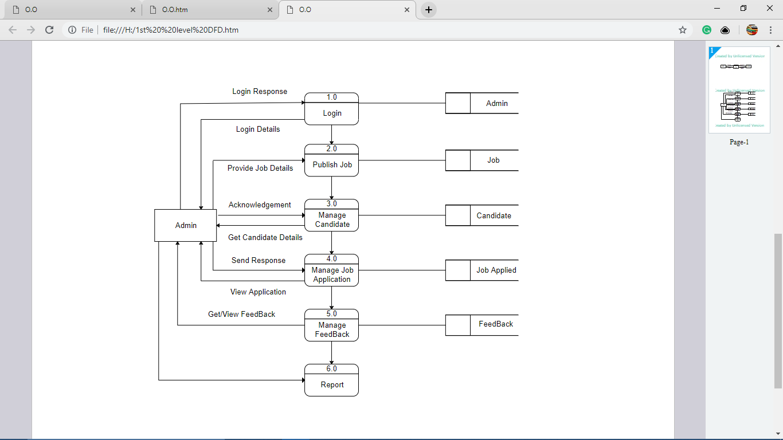

**First level DFD for Candidate:-**

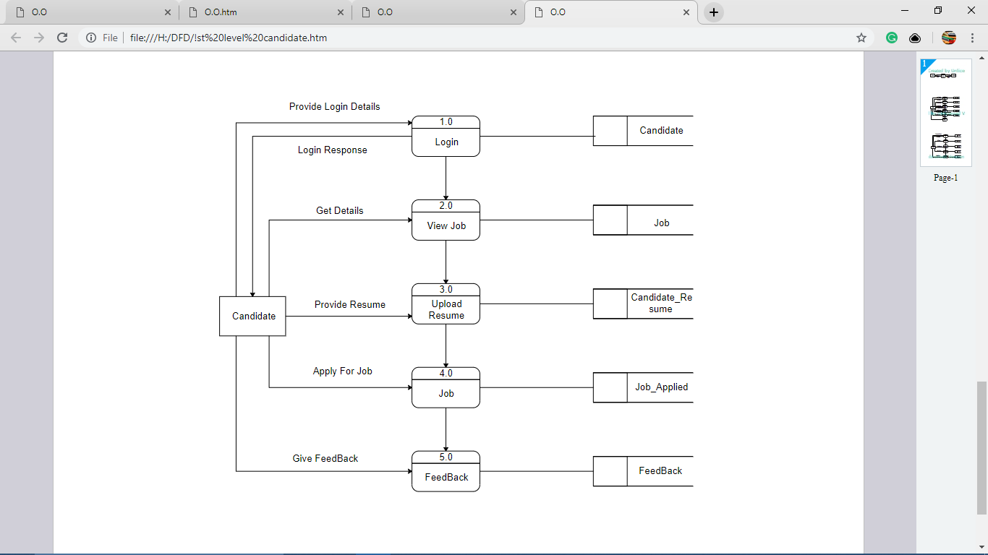

**Entity Relationship Diagram**

**E-R Model:**

E-R model is detailed logical representation of entities , Association and elements for an organization and business area.

**E-R Diagram:**

E-R diagram is a graphical representation of an E-R Model.

This model uses 3 features to describe data. These are as follows:

**1. Entity**

**2. Relationship**

**3. Attribute**

* **Entity:** An entity is a person, place, object, event or concept which system wants to store data.
* **Relationship:** It connects entities and represents meaningful dependency between them.
* **Attributes:**  It specifies properties of entities and relationship. Entity Relationship Diagram consist of a different entities like supplier, owner, customer and stock. This ERD is very easy to understand. Because, in this ERD every entity has different attributes. In ERD these attributes can give the total work or total information of the system. In this candidate registered on the website . Then candidate apply for the job. Admin view job applied by candidate.

**3.2 E-R Diagram**

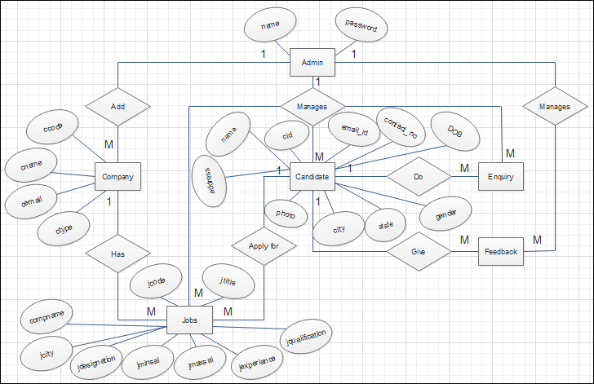

**3.3 Use Case Diagram**

**Use case diagram**

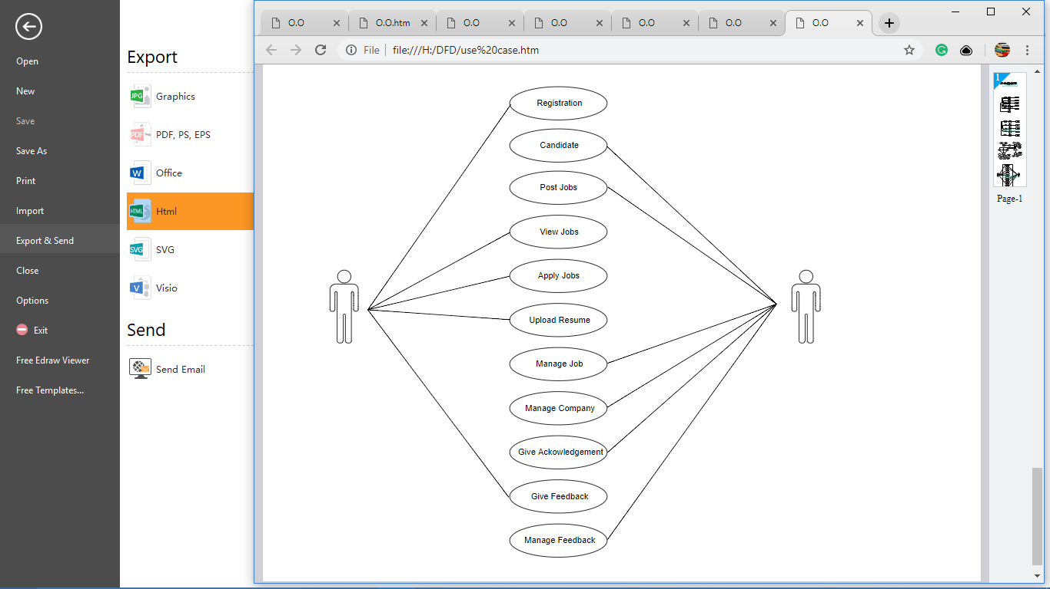

**3.7 Site Map**

Job Portal

Home

About

Services

Sitemap

Contact

Admin login

Add Company

Add

Job

Manage Candidate

Change Password

User login

Report

Manage

Profile

Job

Applied

Jobs

Change Password

Advance Search

**System Design**

**4.1 Database Design**

1. **Login**

**Description:-**

This table includes user name & password, used to provide security

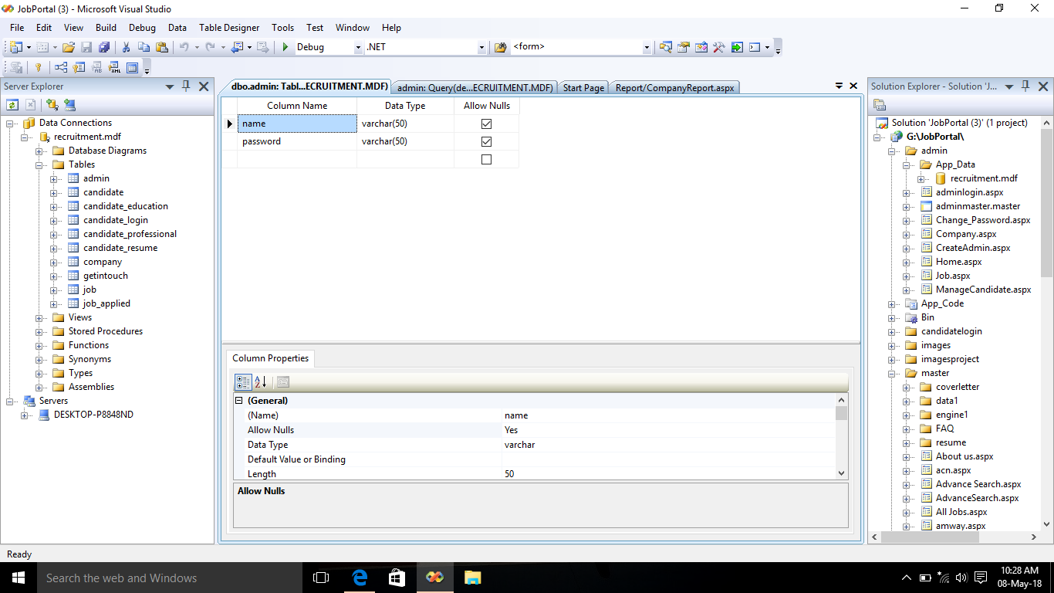

**2.Candidate_login**

**Description:-**

This table includes all the login information of the candidate

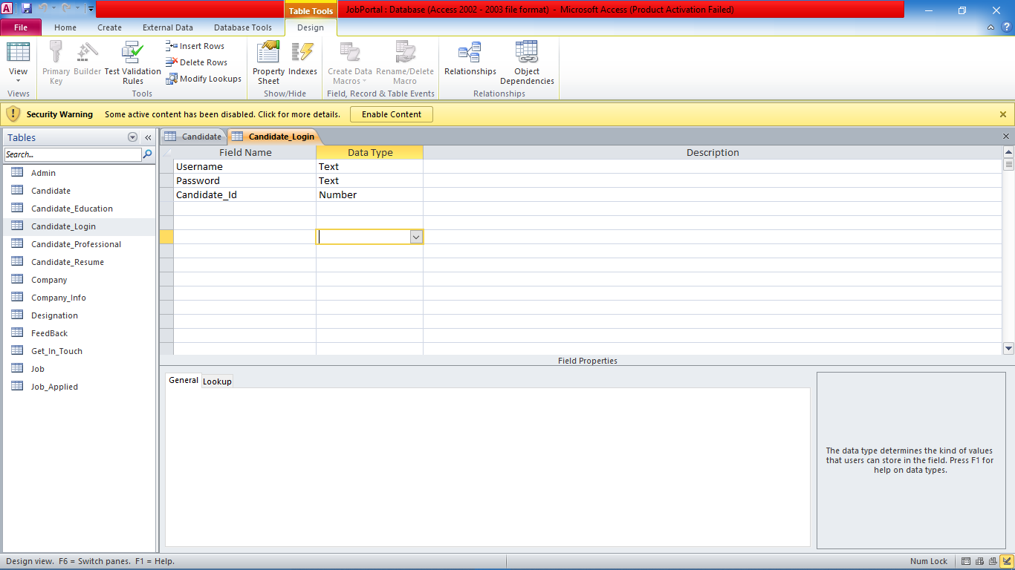

**3. Candidate**

**Description:-**

This table includes personal information of candidate

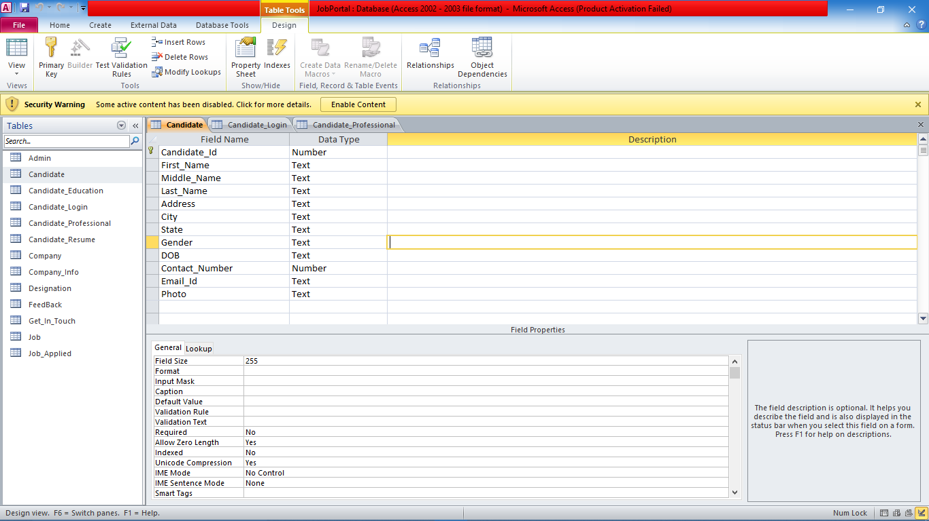

**4. Candidate_Education**

**Description:-**

This table includes all the educational information of the candidate

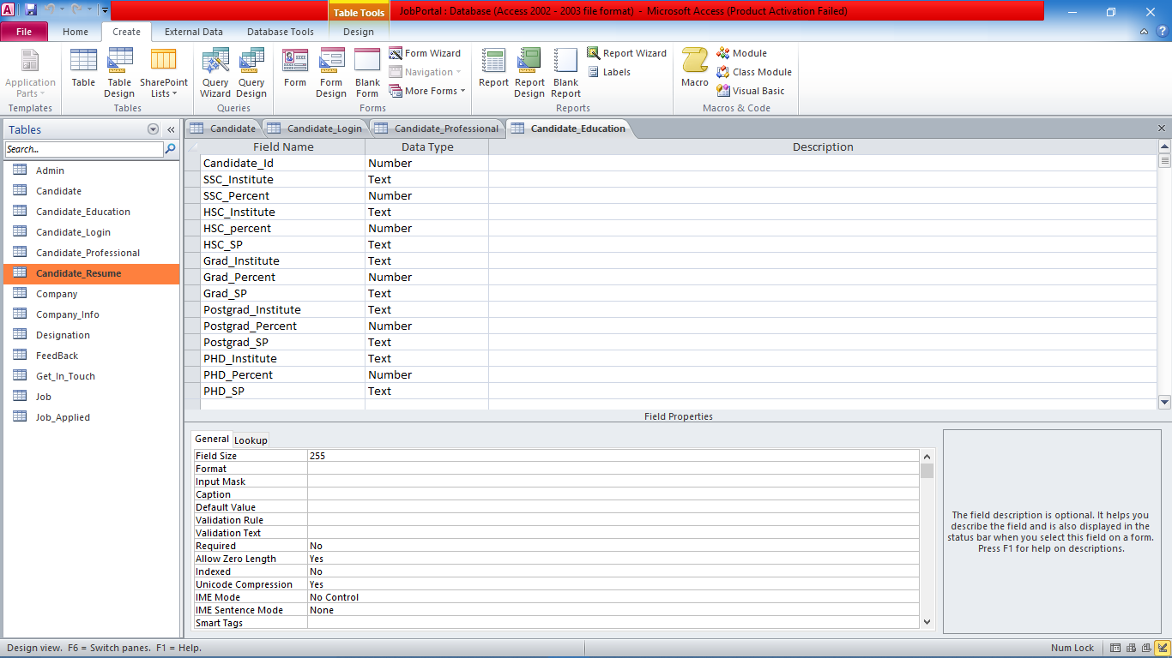

**5. Candidate_Professional**

**Description:-**

This table includes all the professional information about the candidate

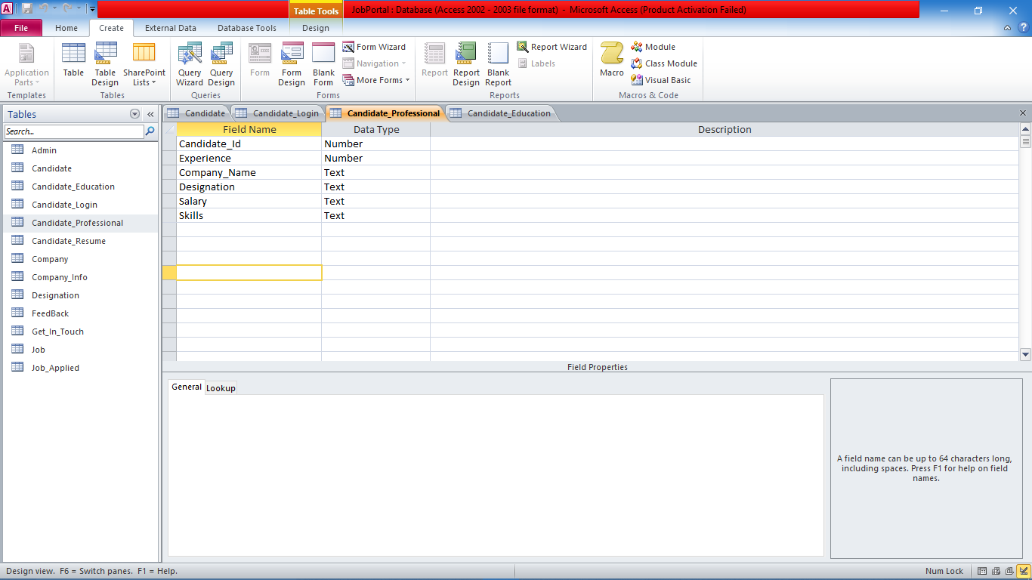

**6. Candidate_Resume**

**Description:-**

This table includes the resume information of candidate

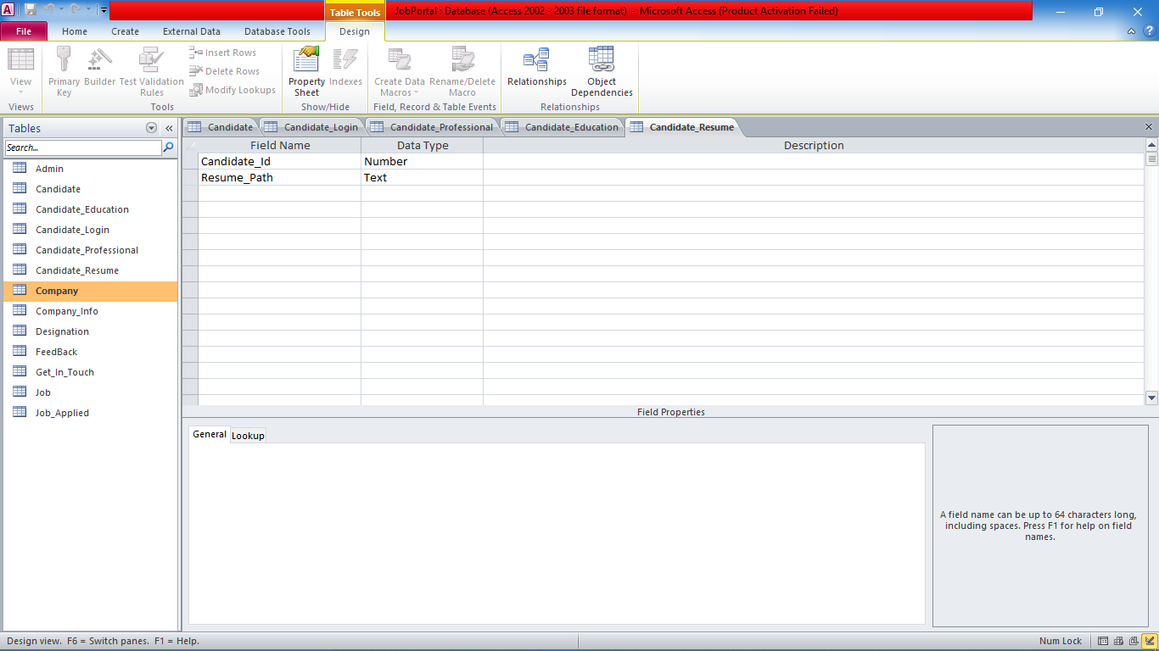

**7. Company**

**Description:-**

This table includes the detail information of company

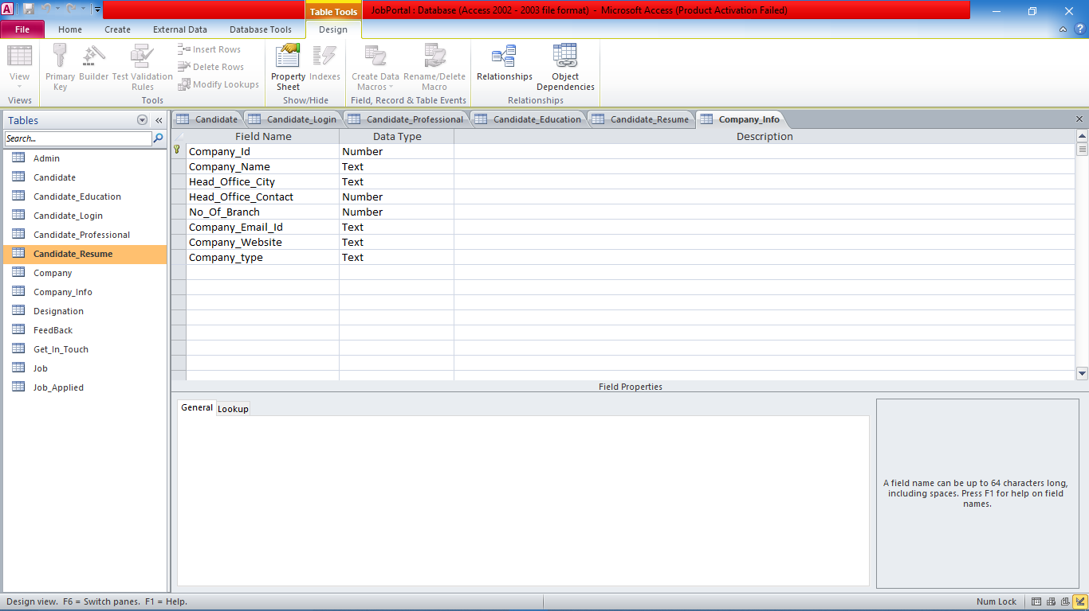

**8. Job**

**Description:-**

This table includes the detail information of jobs

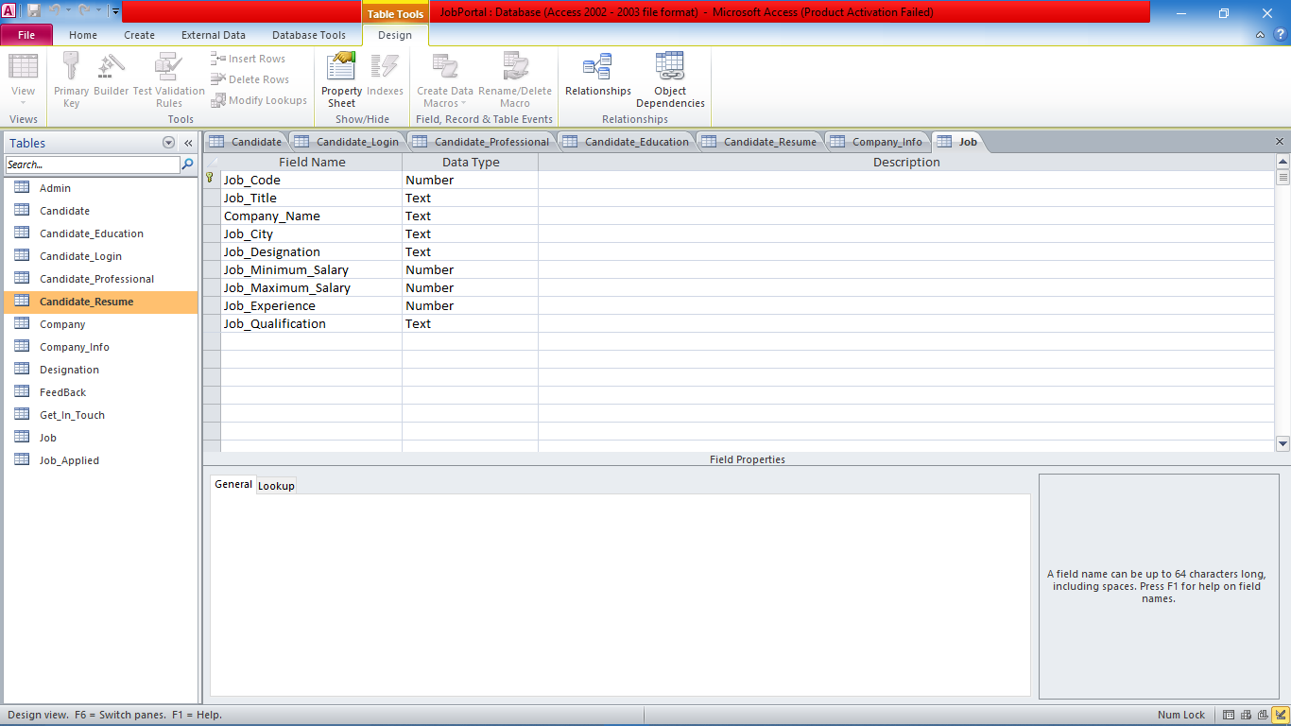

**9. Job_Applied**

**Description:-**

This table includes the detail information of jobs applied

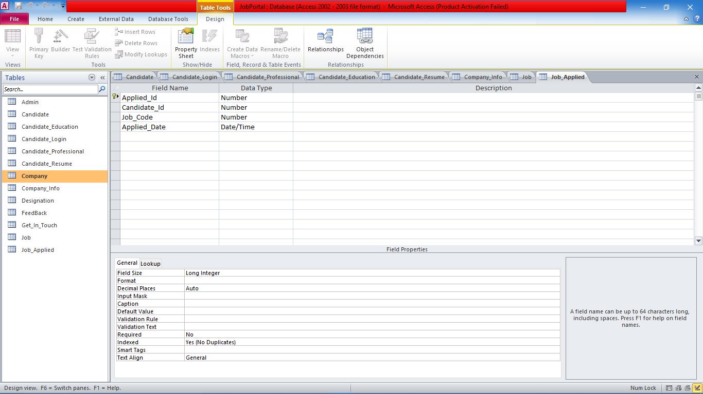

**10. Get_In_Touch**

**Description:-**

This table includes the detail information of feedback

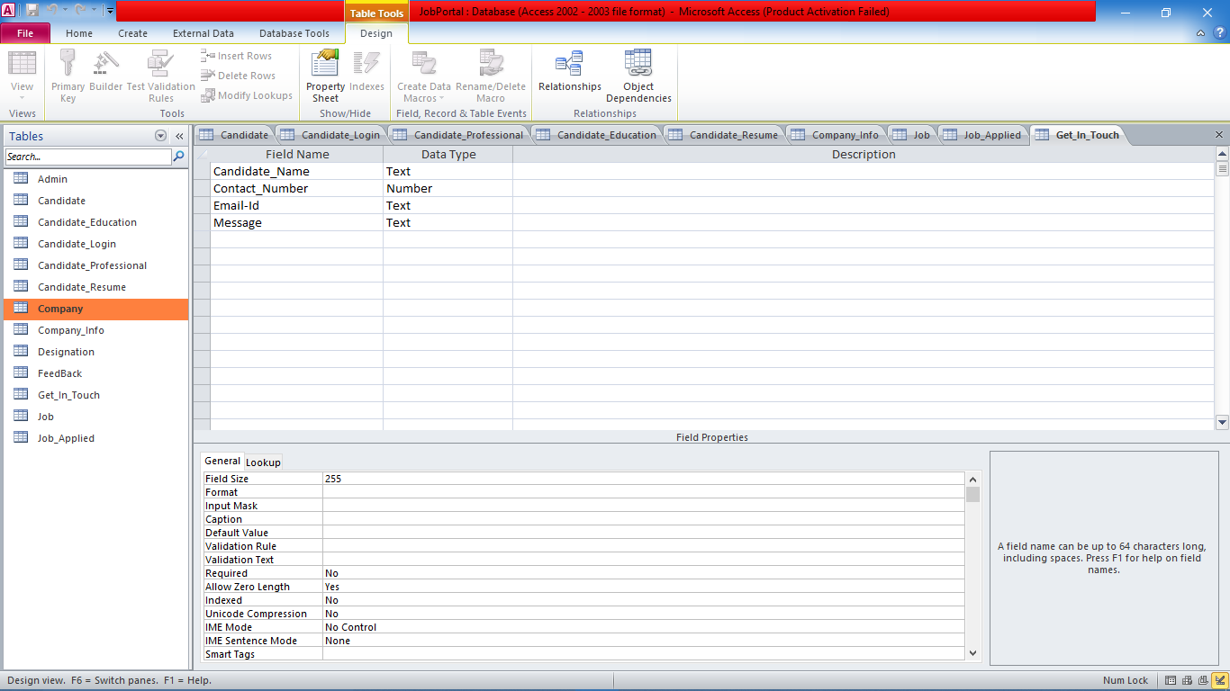

**4.2 Input Design**

**Home Page**

It is home page which contains hyperlinks of about us , services provided , sitemap , contact panel , login.

The different menu’s provided are to search jobs by different categories. We can search jobs by company , by location , by designation , and all jobs.

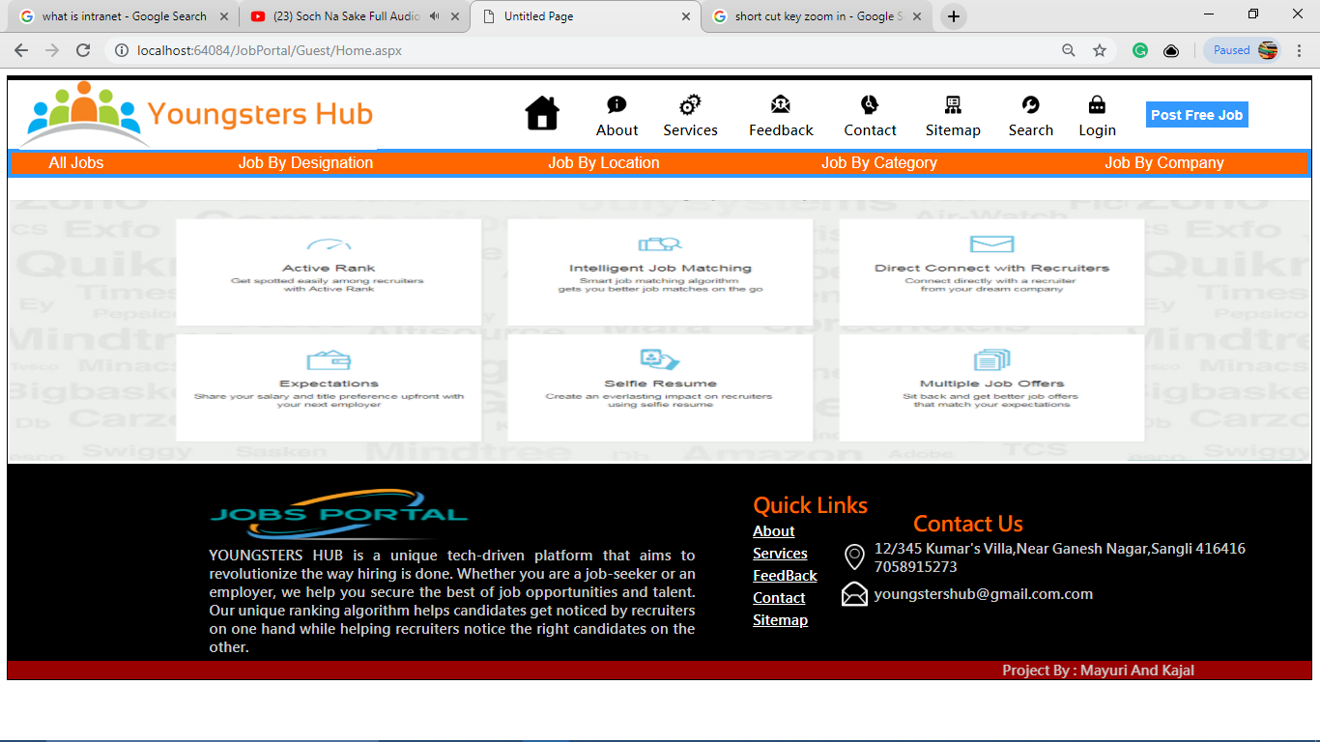

**About**

It is a form having main menu strip contain a forms which are used in the whole system. It contains information about system.

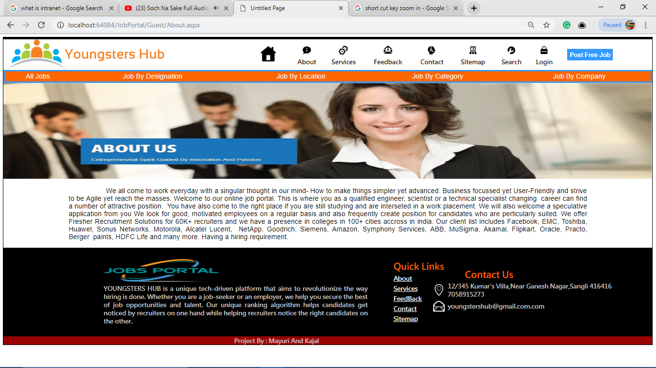

**Services**

It is a form which contains hyperlinks of sample cover letter , resume , interview questions & FAQ’s of different categories.

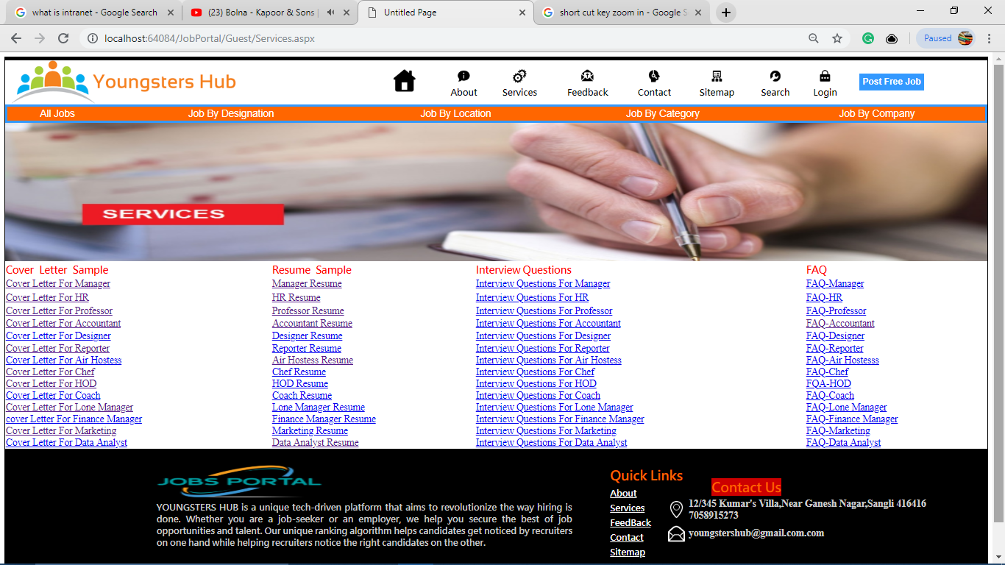

**Cover letter sample**

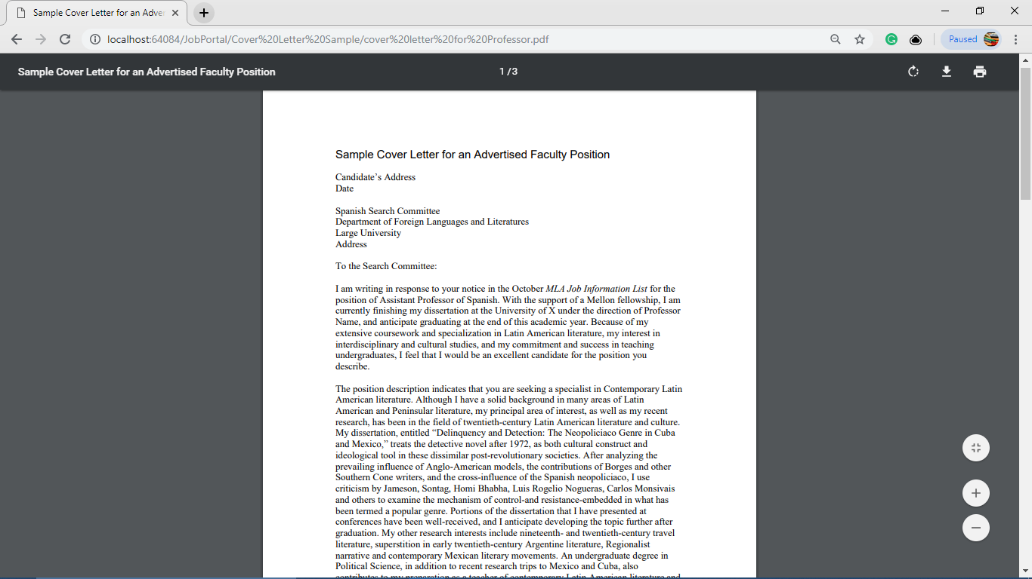

**Resume sample**

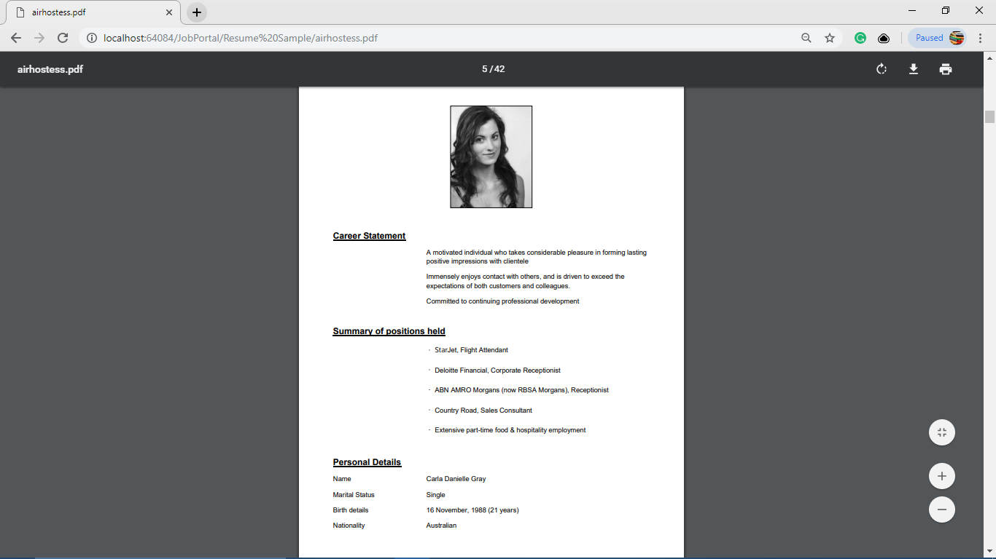

**FAQ’s sample**

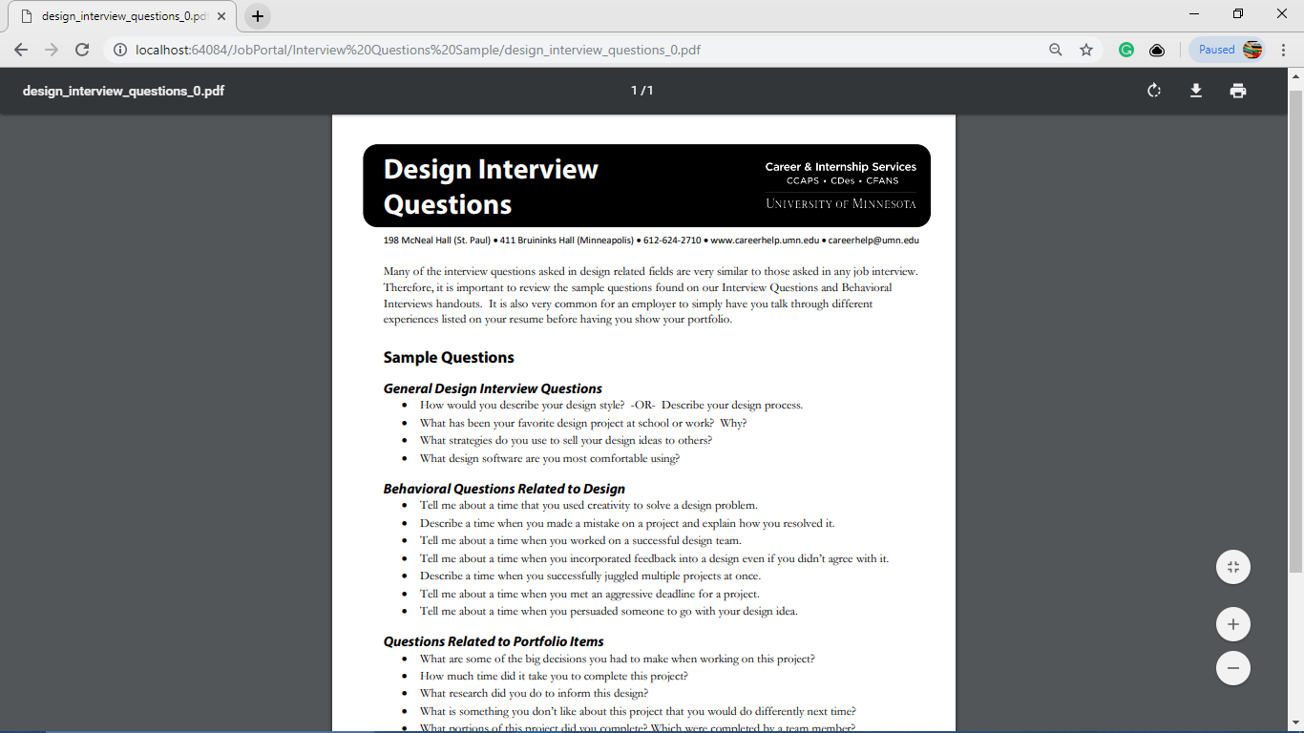

**Interview Sample Questions**

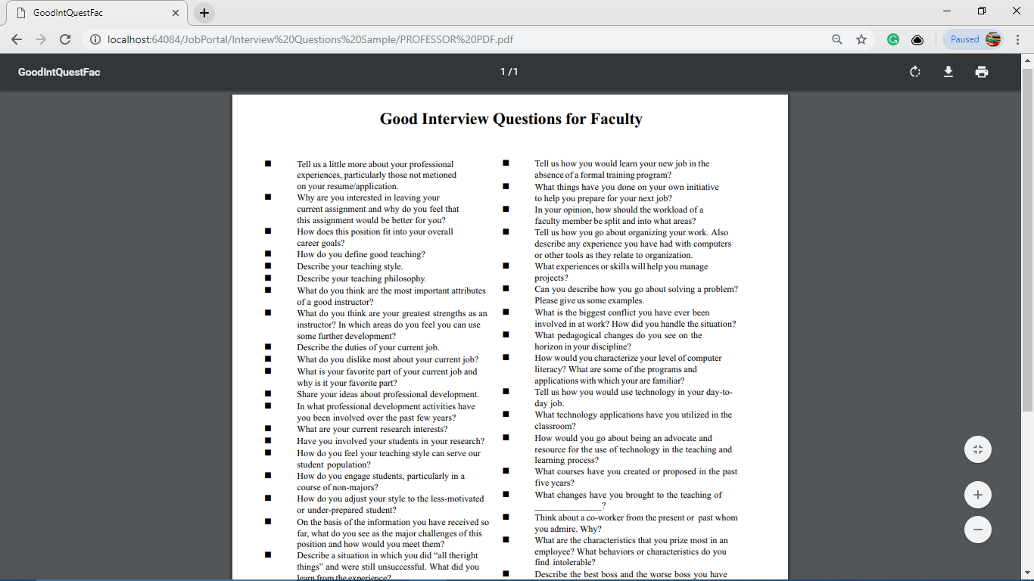

**Sitemap**

This form is used for understanding the system.

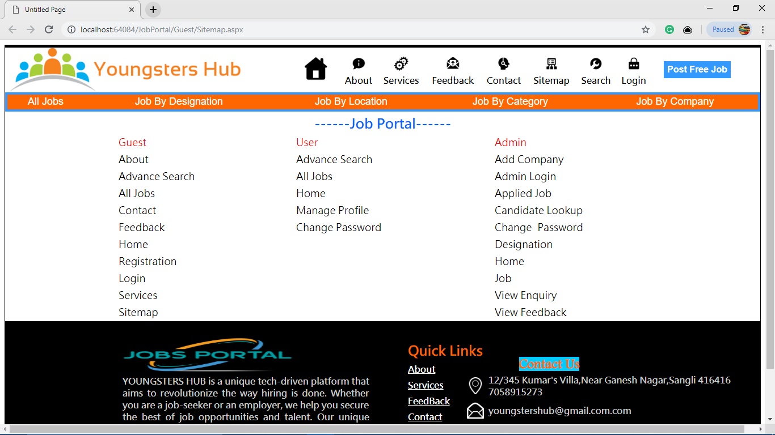

**Contact Form for feedback purpose**

This form is used to save the feedback information.

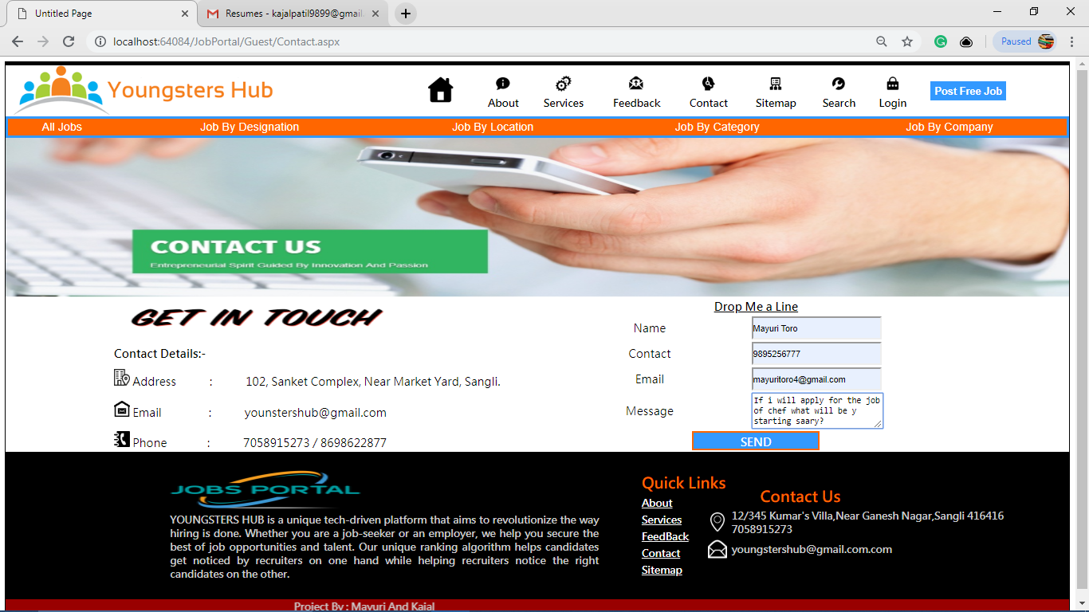

**Login Form**

This form is used by candidate to login.

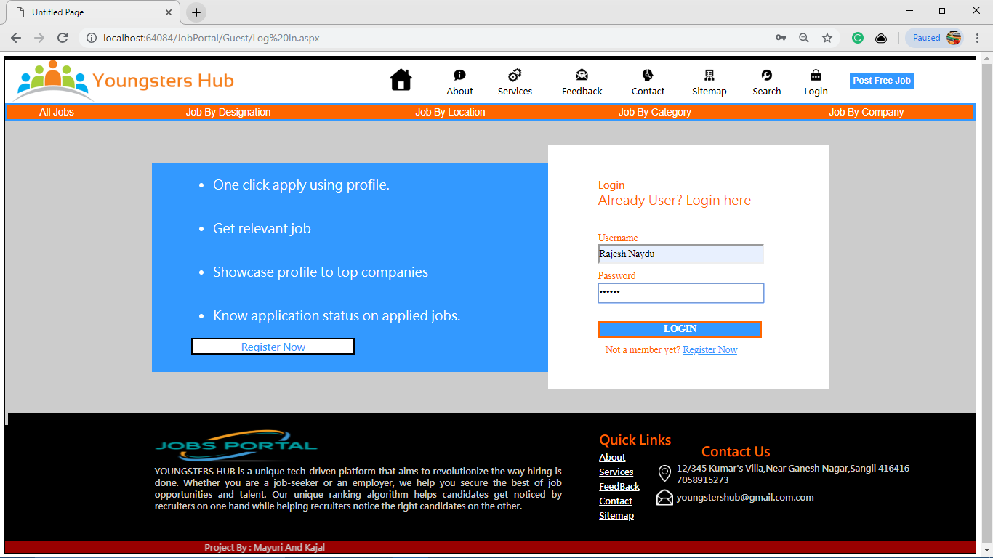

**Registration Form**

This form is used for registration of new candidate.

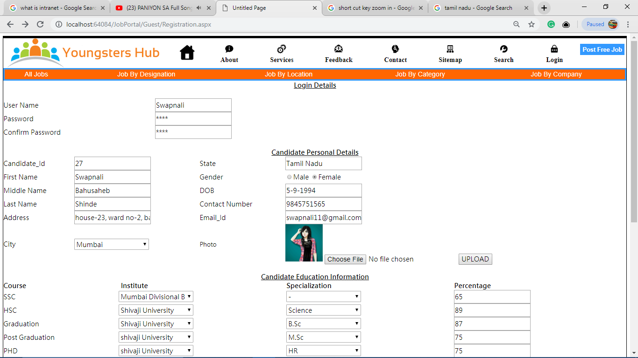

**Candidate Home**

This form is home page used for providing services to candidate who has signin.

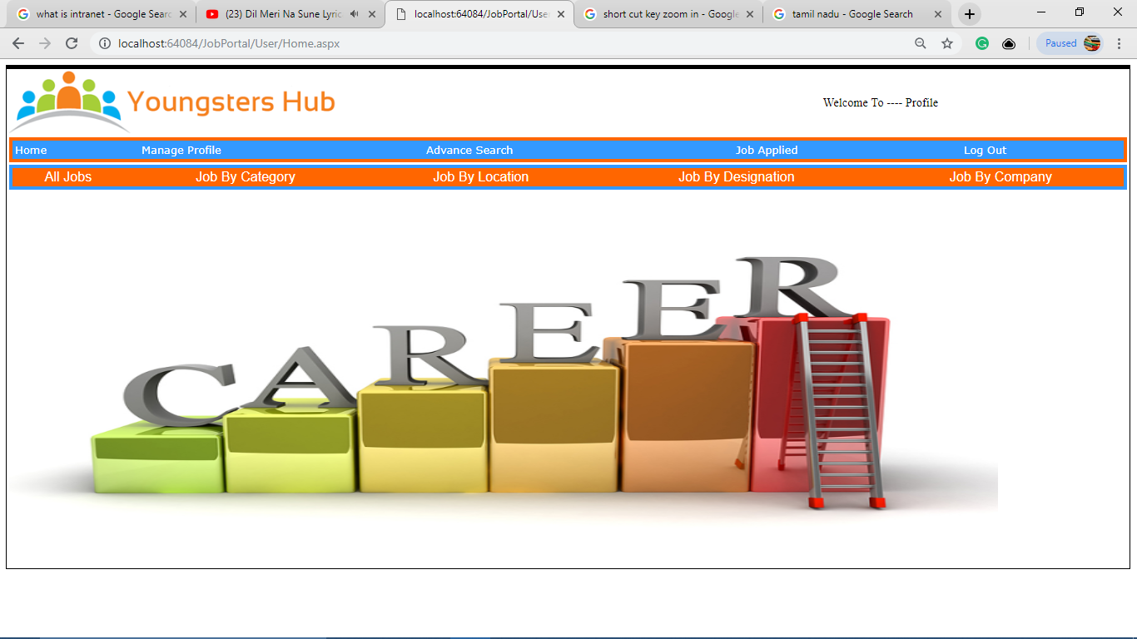

**All Jobs**

This form is used to view all the jobs.

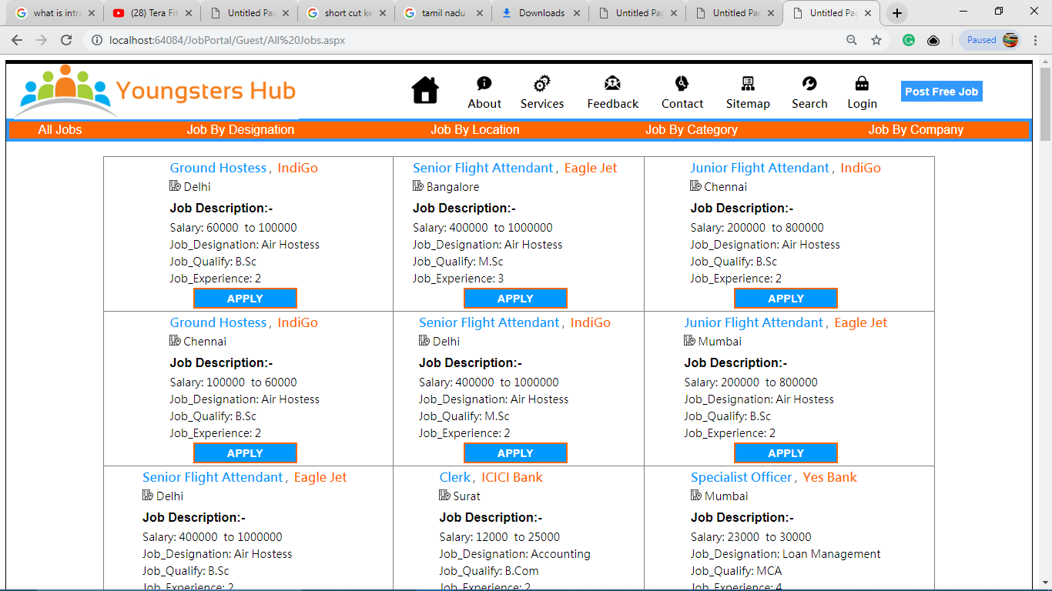

**Post Free Jobs**

The Viewers can also post their jobs.

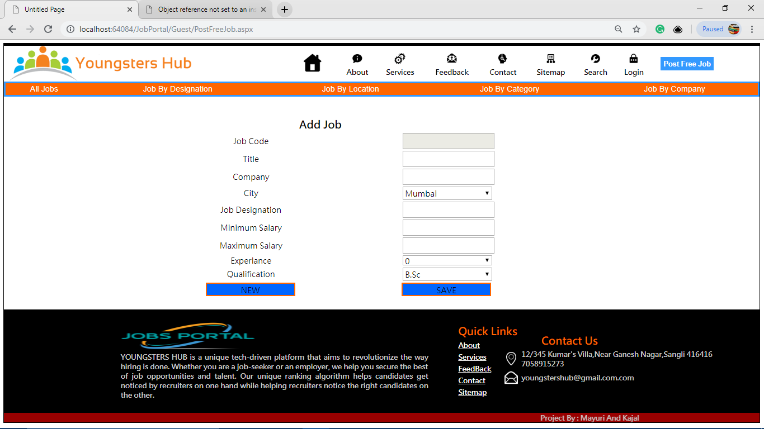

**Jobs by Category**

This form is used to view jobs by category.

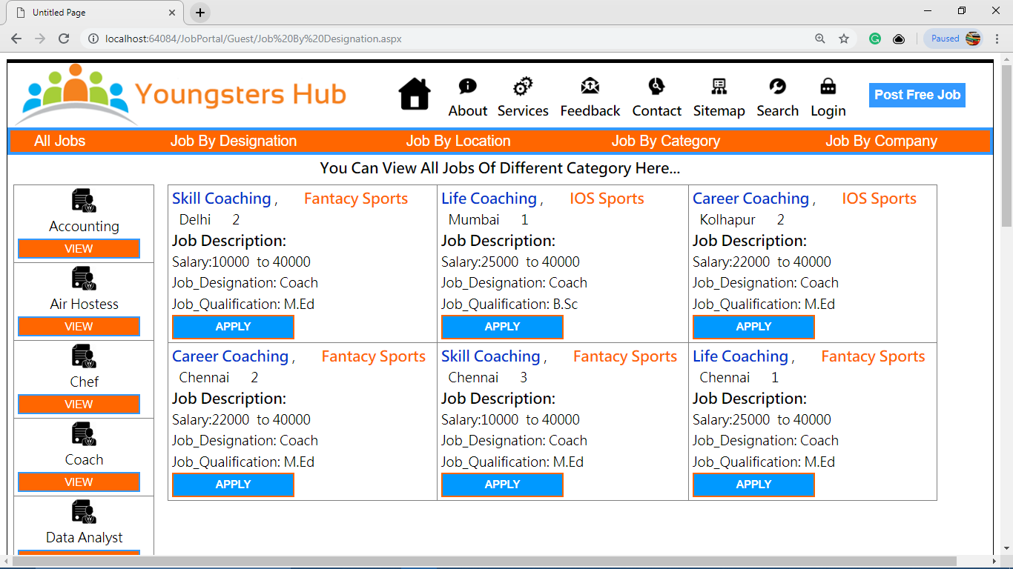

**Jobs by location**

This form is used to view jobs by location.

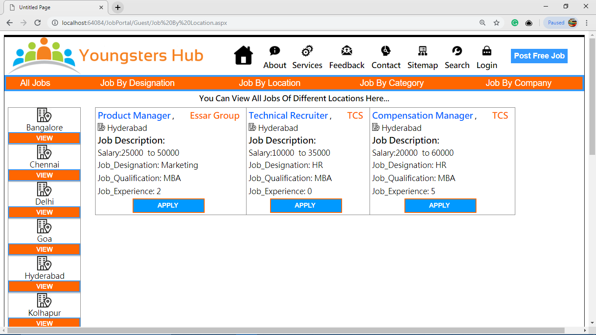

**Jobs by designation**

This form is used to view jobs by designation.

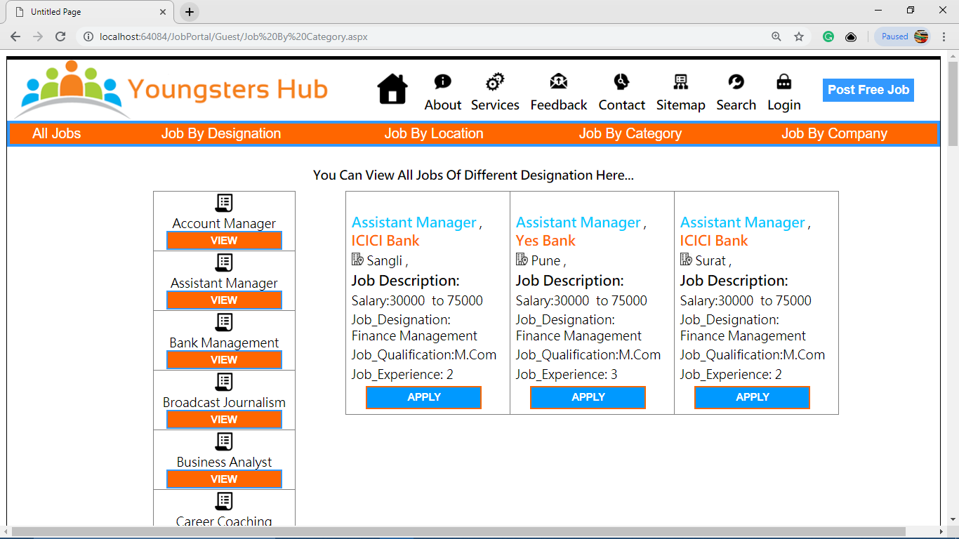

**Jobs by Company**

This form is used to view jobs by company.

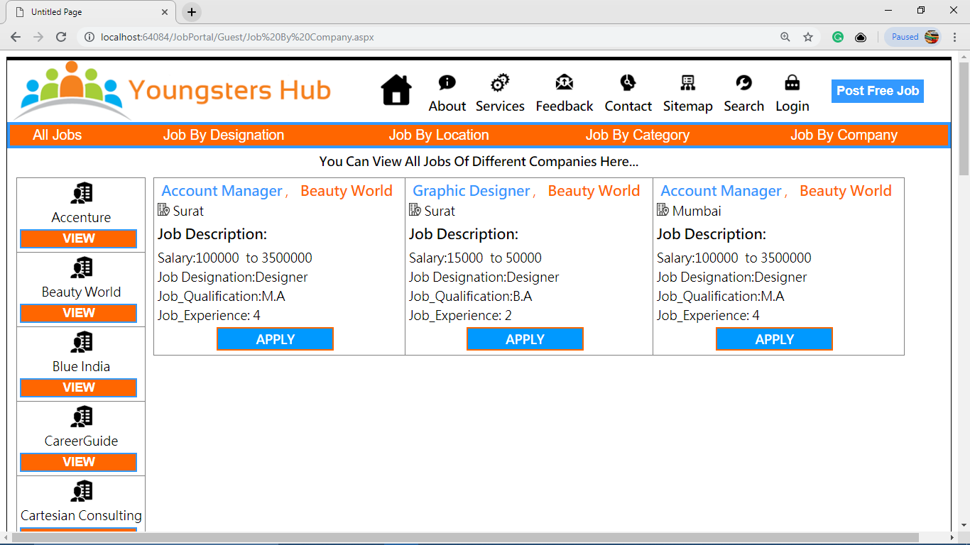

**Manage Profile**

This form is used for managing candidate’s profile. The candidate can update his/her profile.

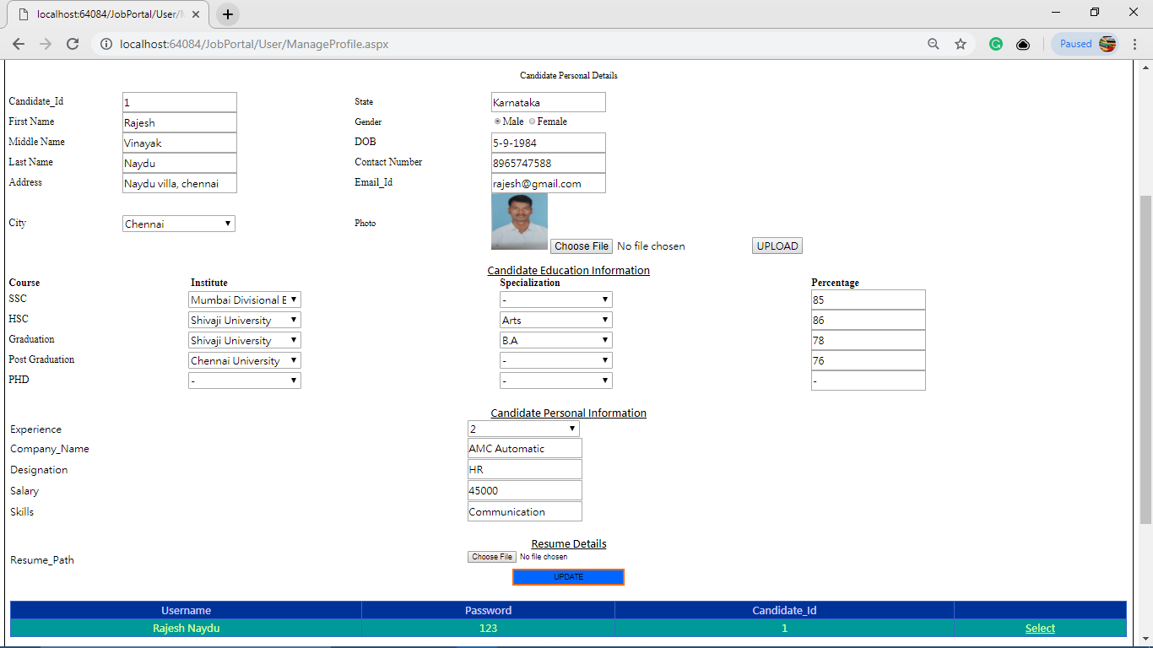

**Advance Search**

This form is used for search the appropriate job. The candidate can also apply for the searched job.

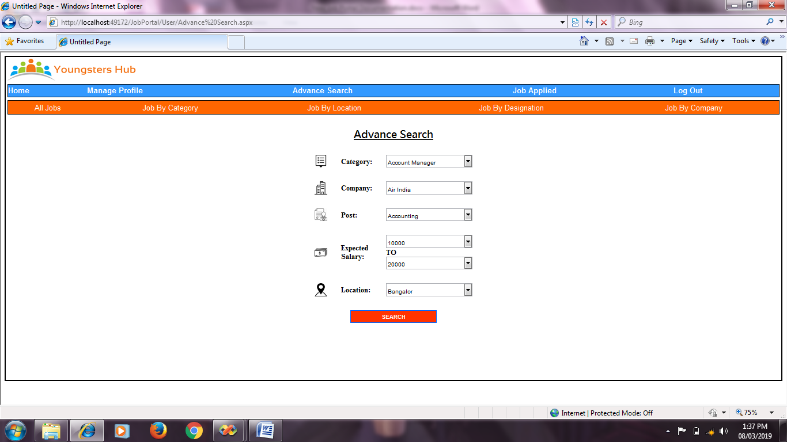

**Job Applied**

This form is used for viewing the jobs applied by candidate.

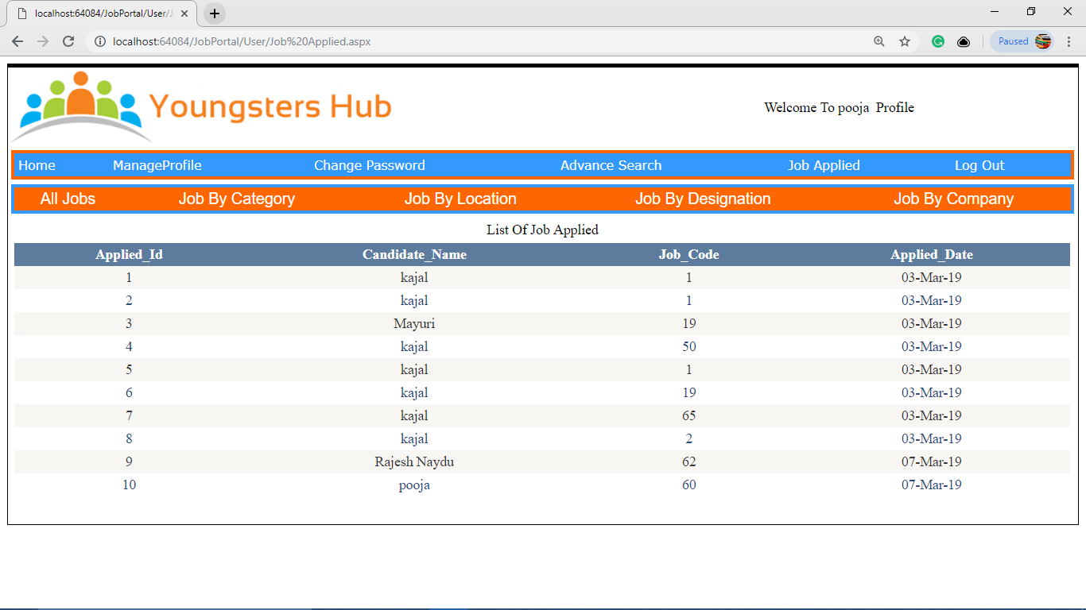

**Change Password**

This form is used to change password of candidate.

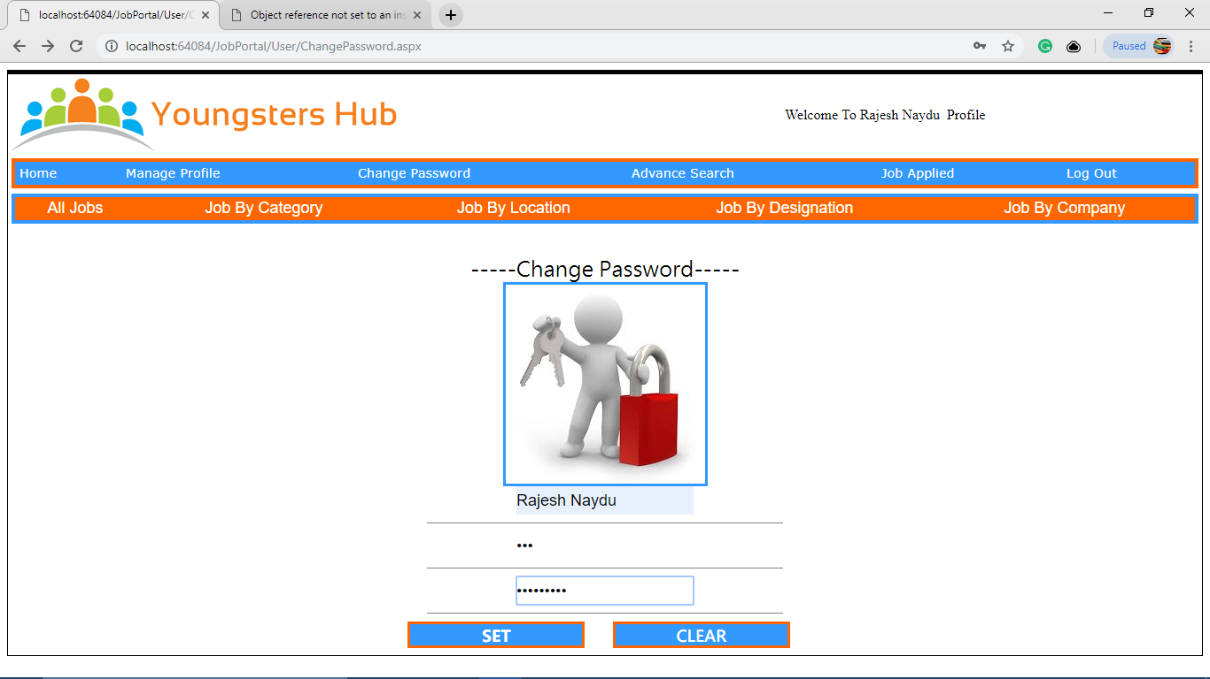

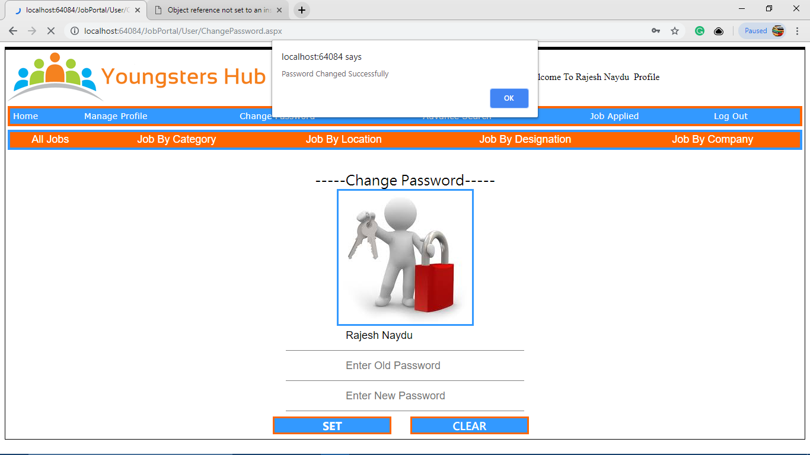

**Admin Login Form**

This form is used by admin to login.

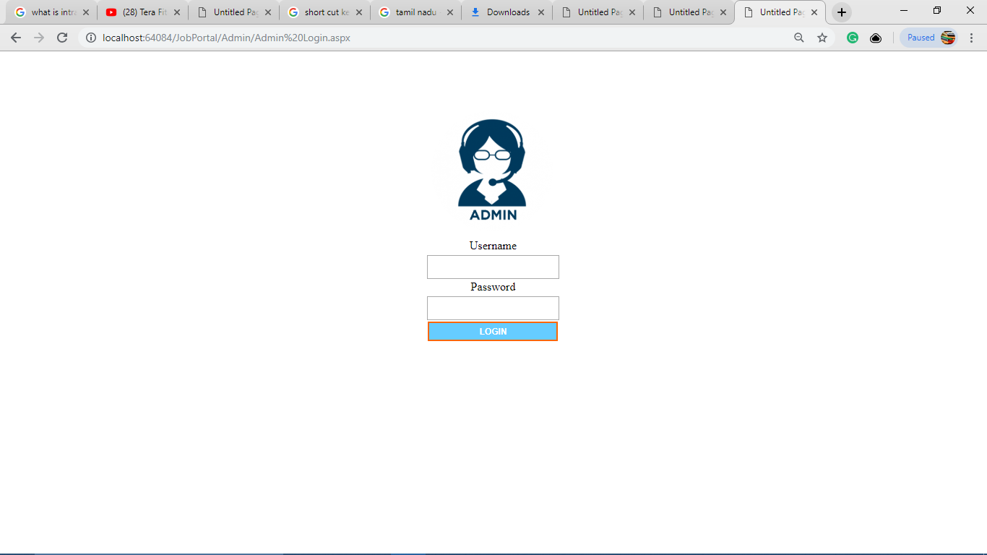

**Admin Home Page**

This form is home page used for providing services to admin who has sign in.

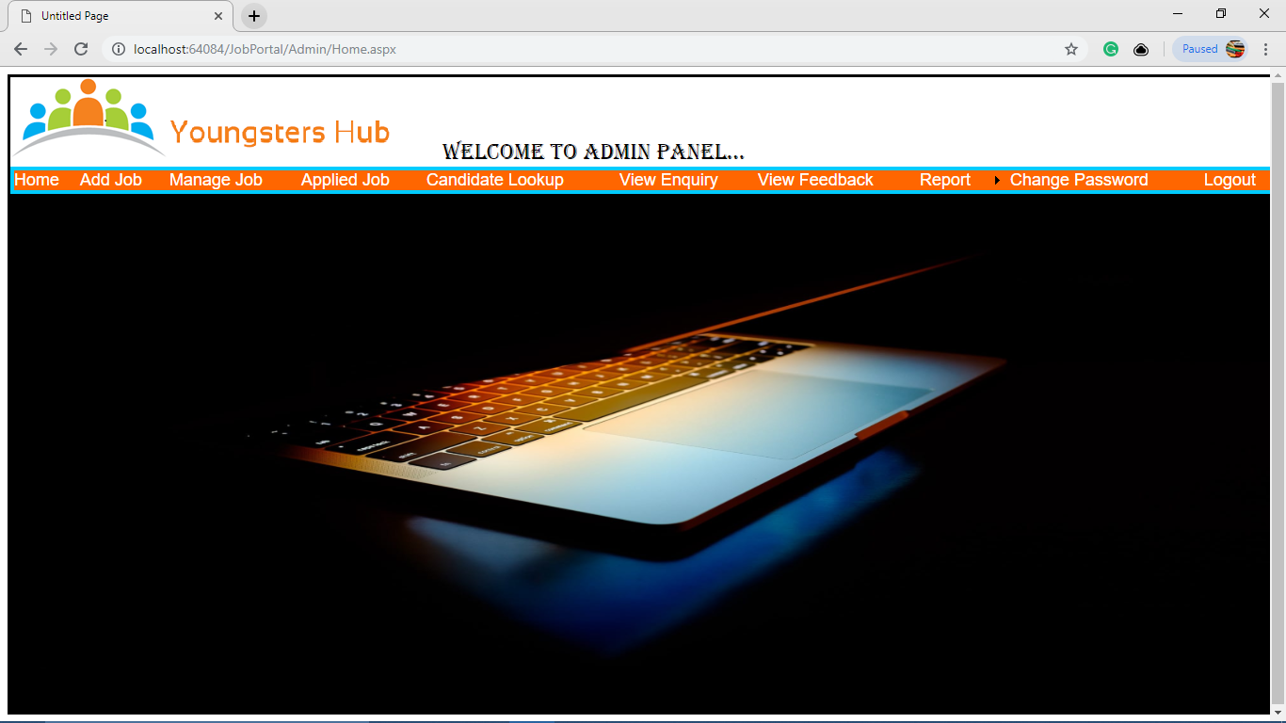

**Add Company**

This form is used by admin to add company.

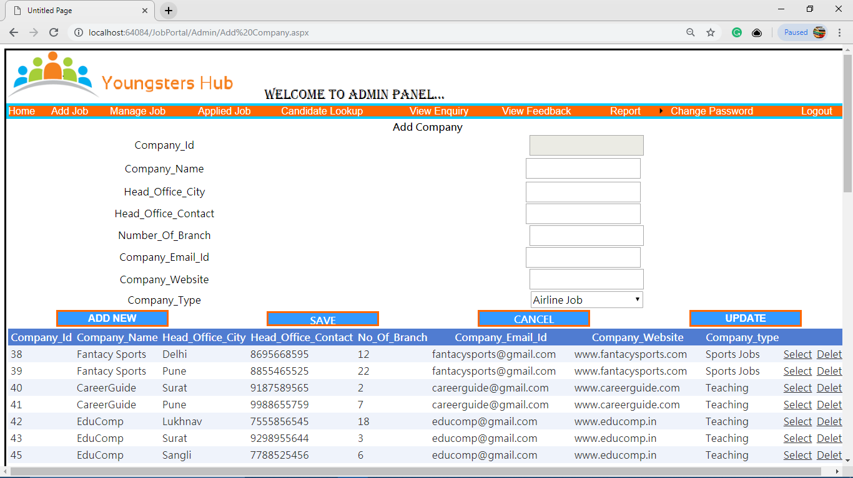

**Add Job**

This form is used by admin to add job.

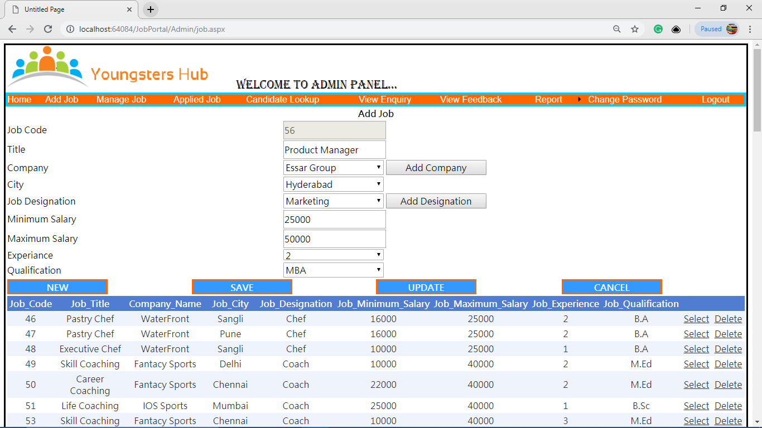

**Manage Candidate**

This form is used to manage candidates.

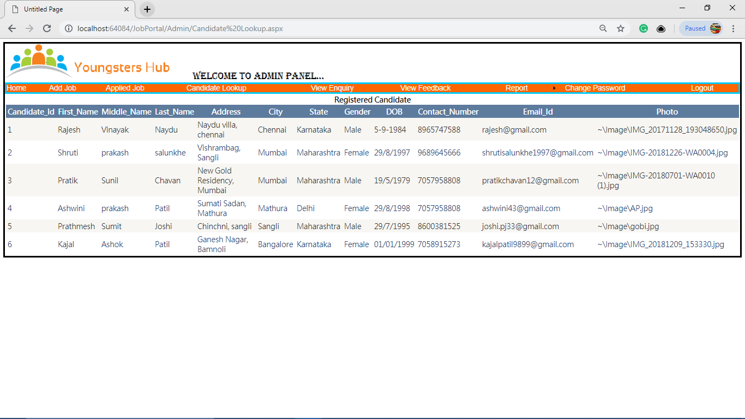

**Change Password**

This form is used to change password of admin.

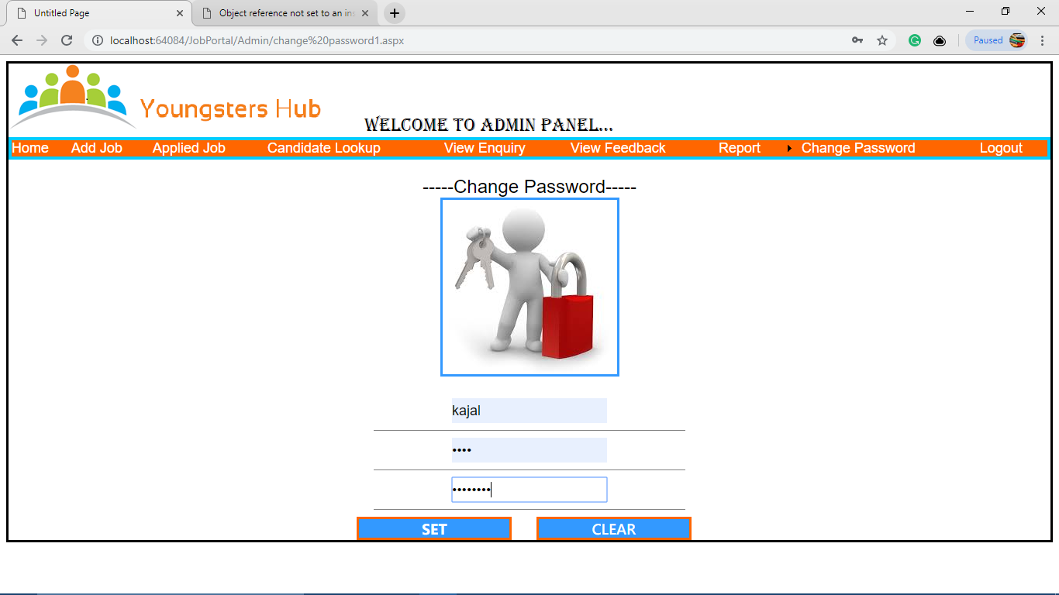

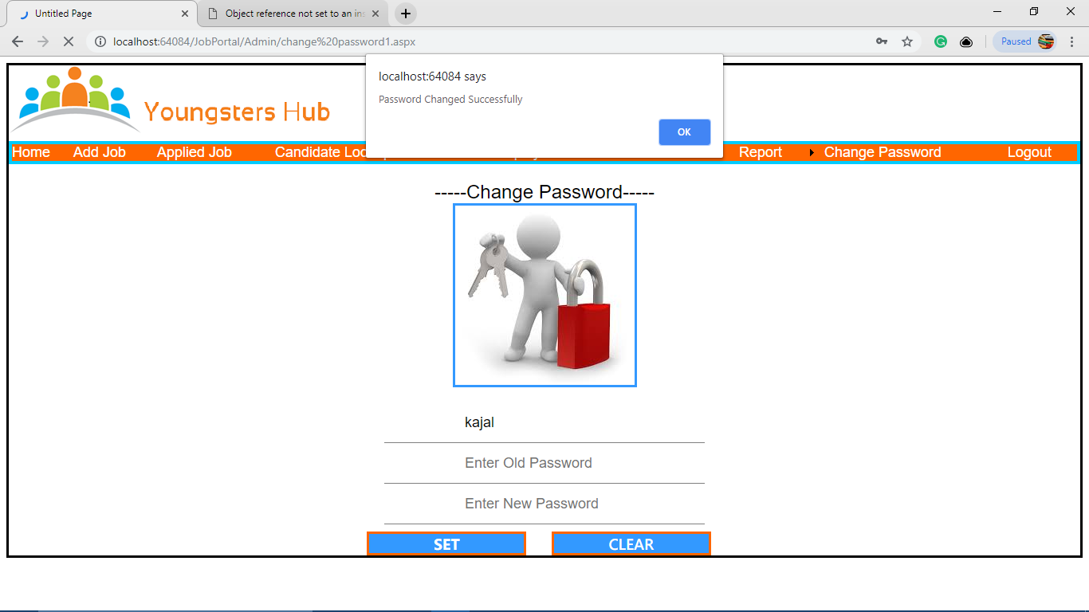

**4.2 Output Design**

**All Candidates List**

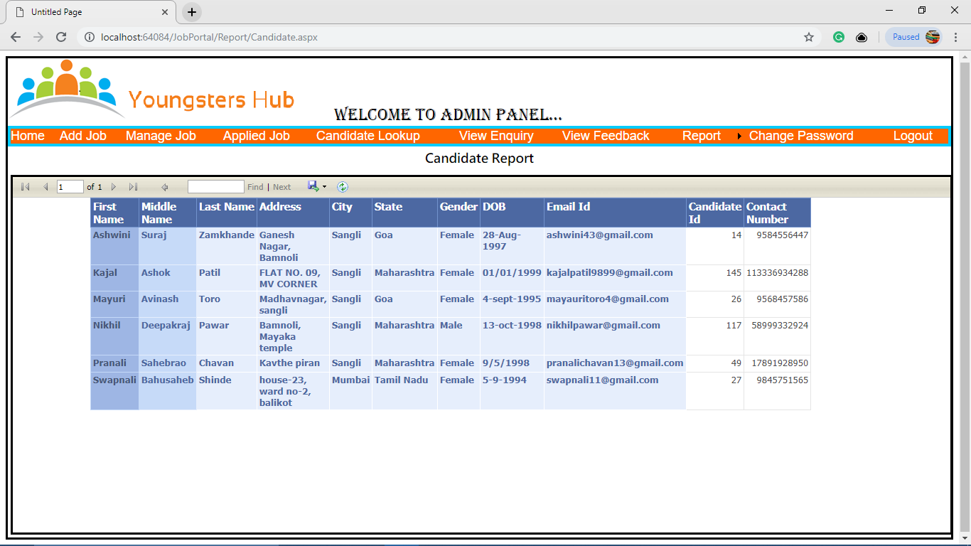

**All Companies List**

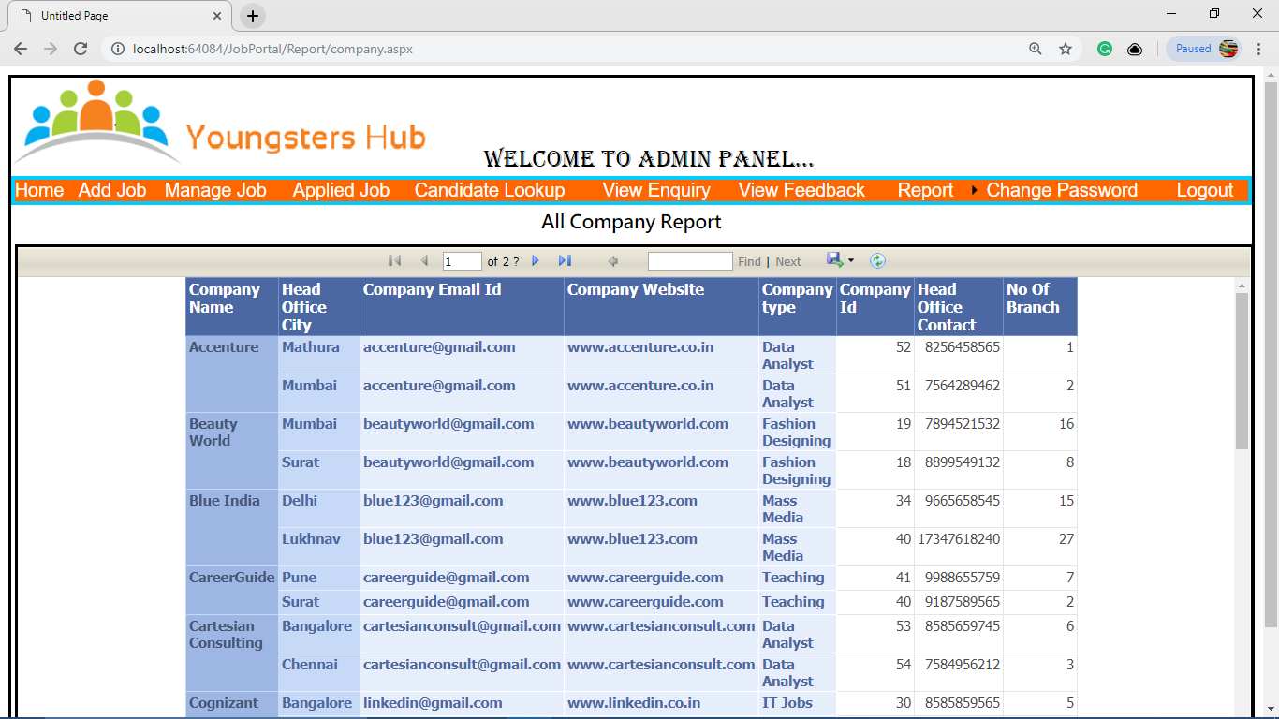

**All Jobs List**

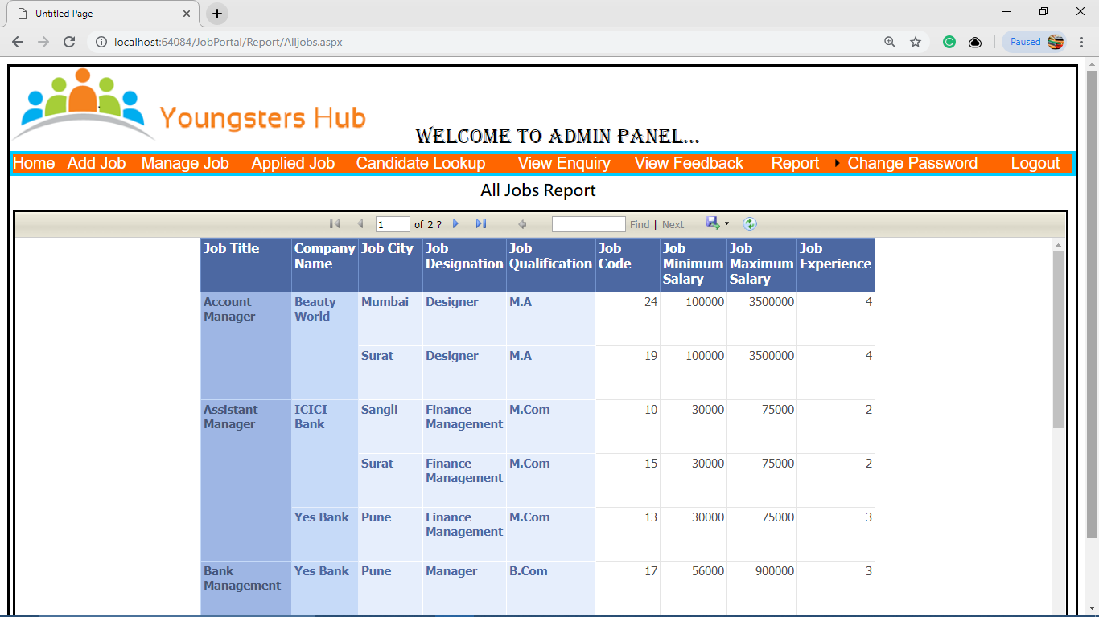

**All Feedbacks List**

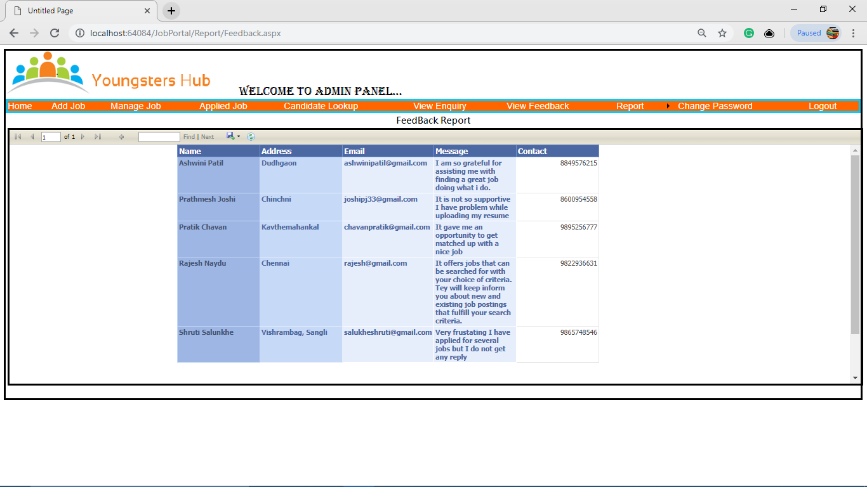

**All Applied Jobs List**

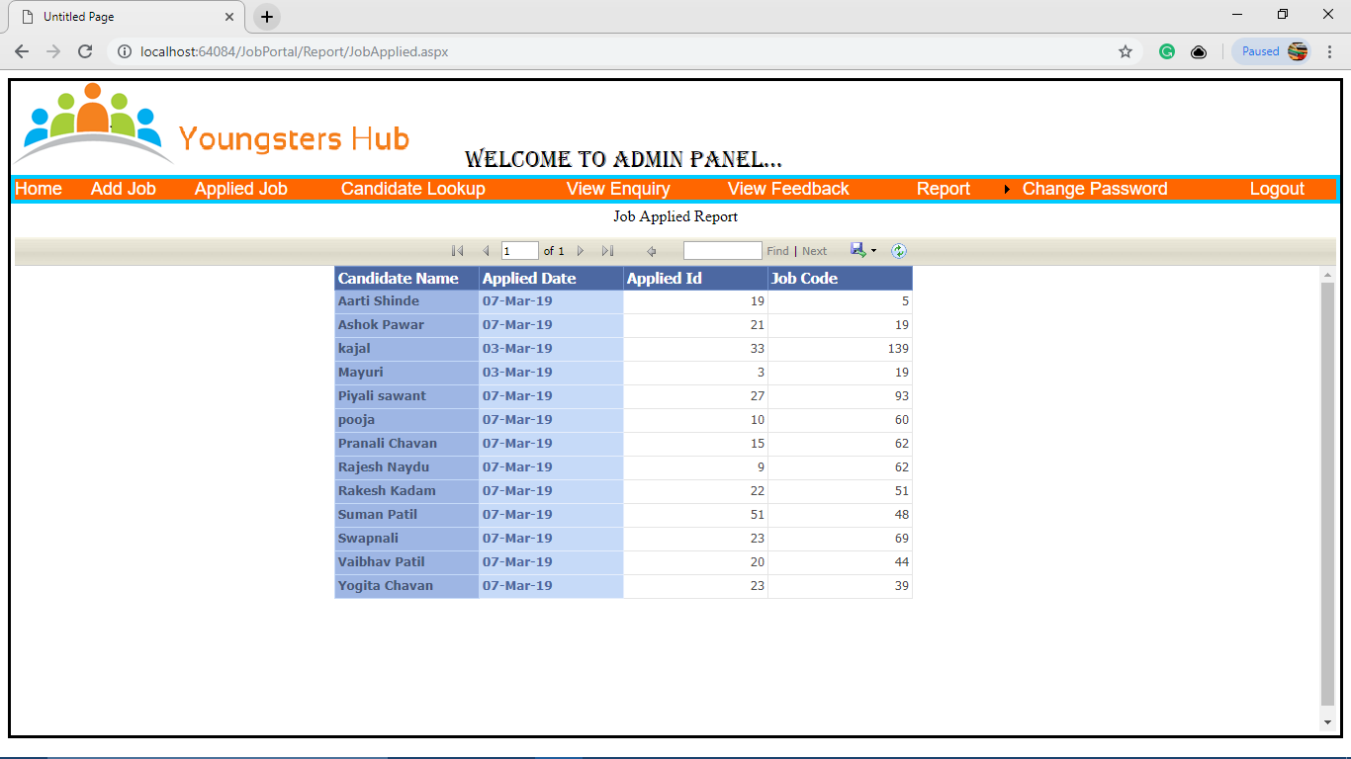

**User Manual**

**User Manual**

The system consist the following modules:

1. Home Master

2. Admin Master

3. Candidate Master

The Home Master module consist the following

* Home - It is home page which contains hyperlinks of about us ,services provided, sitemap, contact panel, login.
* About -It is a form having main menu strip contain a forms which are used in the whole system. It contains information about system.
* Services - It is a form which contains hyperlinks of sample cover letter , resume , interview questions & FAQ’s of different categories.
* Sitemap -This form is used for understanding the system.
* Contact **-**This form is used to save the feedback information.
* Login **-** This form is used by candidate to login.

The Admin Master module consist the following

* Home - This form is home page used for providing services to admin who has signin.
* Add Company - This form is used by admin to add company.
* Add Job - This form is used by admin to add job.
* Manage Candidate - This form is used to manage candidates.
* Change Password - This form is used to change password of admin.
* Add Admin - This form is used to add admin.
* Report - This shows different reports.
* Logout - this is used to admin logout.

The Candidate Master module consist the following

* Home - This form is home page used for providing services to candidate who has signin.
* Manage Profile - This form is used for managing candidate’s profile. The candidate can update his/her profile.
* Advance Search - This form is used for search the appropriate job. The candidate can also apply for the searched job.
* Job Applied - This form is used for viewing the jobs applied by candidate.
* Change Password - This form is used to change password of candidate.
* Logout - this is used for candidate logout.

**Future Enhancements**

**&**

**Limitations**

**Future Enhancements**

This project is completed but still they want to update and modify some modules.We are always thinking about Guest requirements also growing day by day. Wealways want toimplement something more. We will add new feature like User is able to easily cancel their registeration. We will provide paid packages with more services. In this website admin adds the jobs of different companies , but in future we can give access to various companies to add their jobs , which can be viewed by job seekers. It is also possible to provide sms alerts of job openings to the job seekers.

**Limitations**

We do not implement deployment process.Also company does not have access to add jobs.The jobseeker does not get job alerts suitable for them.The system does not support paid services.

**Conclusion**

**Conclusion**

* This system is designed for the placement agency. The main purpose of the system is to provide benefits to job seekers to find job by different criteria and also apply to that job.
* The software can keep records & details of the candidate , company , job in a systematic manner .So that it can be accessed by user easily as per their requirements.
* This system also provides different services to jobseeker for writing resume & cover letter , also provides FAQ’s for facing the interview.
* The system provides facility of advance searching by finding job by company , by location , by designation , etc.

**References**

**References**

During the development of our system, we have taken the reference from

various books and journals, which we would like to mention in thissection.

1. **Reference books**

* ASP.Net With C# by Shyam N. Chavda
* ASP.NET 3.5 Black Book

1. **Websites**

* [www.google.com](http://www.google.com)
* [www.sourcecode.com](http://www.sourcecode.com)
* [www.naukri.com](http://www.naukri.com)